Catapult model final report

**Objective:**

The objective of the experiment is to perform the catapult operation and to find out the future predicted values using a 23 full factorial design with 3 factors two levels each.

**Design:**

The catapult consists of five controllable variables with different levels.

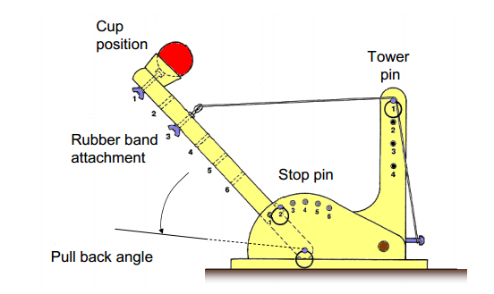

|  |  |  |
| --- | --- | --- |
| **Controllable variable** | **Levels** | **Comment** |
| Pull back angle | 90 to 180 degrees | Continuous variable |
| Stop pin | 1 to 6 | Categorical variable |
| Tower pin | 1 to 4 | Interaction with pull back |
| Cup position | 1 to 6 | Interaction with rubber band attachment |
| Rubber band attachment | 1 to 6 | Interaction with cup position |

**Variables investigated:**

The input factors are stop pin, tower pin and the cup position. The pullback angle and rubber band attachment are kept constant.

The table below shows the various input factors and their corresponding levels for the experiment:

|  |  |  |  |
| --- | --- | --- | --- |
| **Factors** | **Input factor** | **High level (+)** | **Low level (-)** |
| A | Cup Position | 5 | 2 |
| B | Tower Pin | 4 | 2 |
| C | Stop Pin | 5 | 2 |

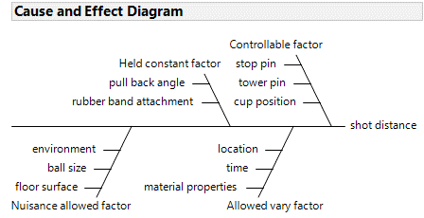

**Cause and effect diagram**

**Materials:**

1. Catapult equipment with ball
2. Aluminum foil
3. Masking tape
4. Measuring tape

**Procedure:**

1. Place the catapult on the floor usually on the flat surface.
2. Roll the aluminum foil on the floor opposite to the catapult so that the ball length to be measured can be easily marked using the foil.
3. Using masking tape fix the foil in the corners.
4. Measuring tape should be aligned with the aluminum foil.
5. Make sure the measuring tape is placed from the start of the catapult till the other end.
6. Now based on the input factors and levels, the ball showed be launched.
7. Once the ball pitch the foil, measure the shot distance using measuring tape.
8. Repeat the same procedure for all factors and levels while measuring the shot distance.
9. Make sure forming a data table with all the readings randomly and note the shot sequence.
10. Analyze with respect to various factors.

**Data table:**

|  |  |  |  |  |  |  |  |  |
| --- | --- | --- | --- | --- | --- | --- | --- | --- |
| Run order | Shot sequence | Factor | | | Distance | | | |
| A | B | C | Run 1 | Run 2 | Run 3 | Run 4 |
| 1 | 2 | - | - | - | 91.8 | 92.6 | 98. | 96.2 |
| 2 | 7 | - | - | + | 97.7 | 98.2 | 97.7 | 98.2 |
| 3 | 5 | - | + | - | 46.6 | 45.7 | 43.1 | 44.7 |
| 4 | 4 | - | + | + | 47.3 | 48.7 | 50.4 | 51.4 |
| 5 | 3 | + | - | - | 47.8 | 47.4 | 47.2 | 49.2 |
| 6 | 6 | + | - | + | 74.8 | 72 | 75 | 64.9 |
| 7 | 1 | + | + | - | 20.8 | 23.4 | 22.4 | 22.5 |
| 8 | 8 | + | + | + | 6.6 | 5.5 | 5.5 | 5.8 |

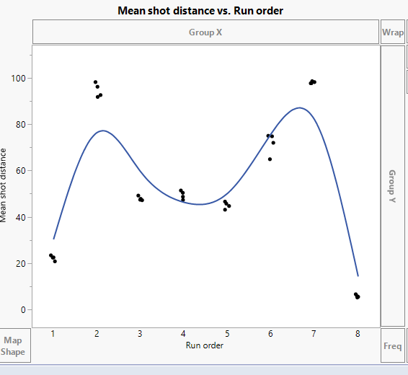

The graph between mean shot distance vs run order shows that there is some drift in run 2, 6, 7, 8.

**Data table in jmp:**

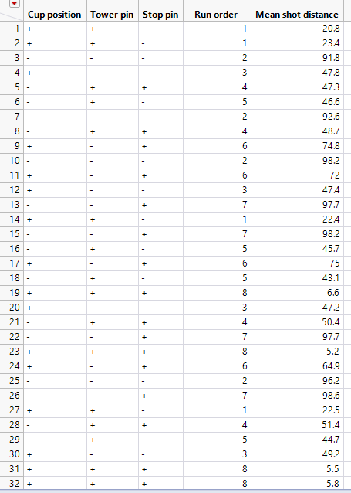

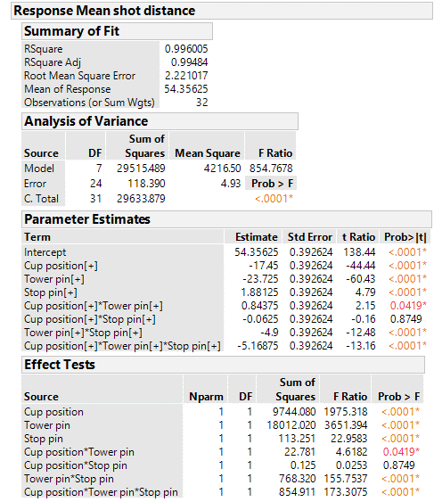

From the effect tests, except for the two interaction of factor (cup position * stop pin) all other factors and two interactions are significant as the p-value is smaller than α = 0.05

The overall F – statistic of the model is large with a very small P – value; there is strong evidence that at least one of the factors is different and influence the response.

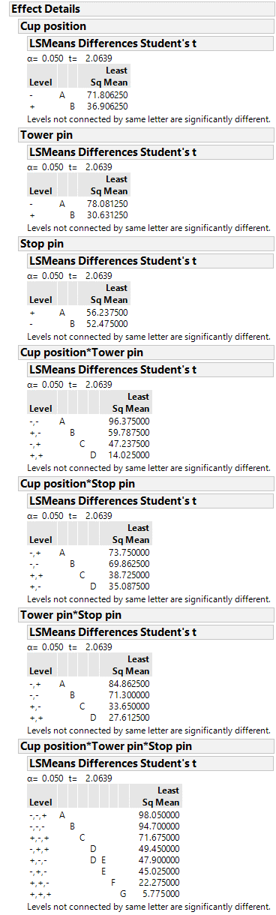

From the connecting letters report of three factor interaction it could be seen that the means of -,+,+ &+,-,- and +,-,-&-,+,- are same. All the other levels that are not connected by the same letter are significant at $α=0.05$

From the connecting letters report of two factor interaction it could be seen that the means of two levels are different at $α=0.05$

From the connecting letters report of single factor it could be seen that the means of two levels are different at $α=0.05$

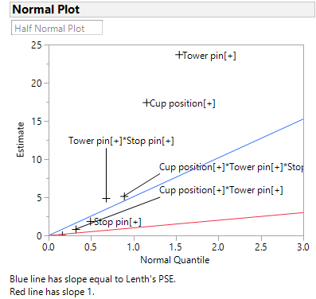

From the half normal plot, we can see that all factors are significant except the interaction between cup position and stop pin and interaction between cup position and tower pin are not significant.

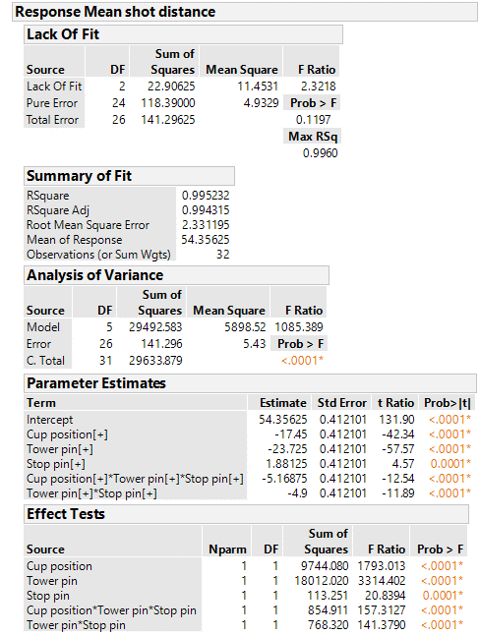

In the reduced model it can be seen that all the five factors that are chosen are significant at $α=0.05$

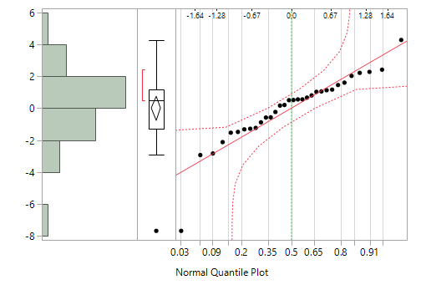

From the normal quantile plot of residuals it could be seen that except two points all the other points lie close to the line and it’s within the error bounds. Therefore there is no significant deviation of the normality assumption.

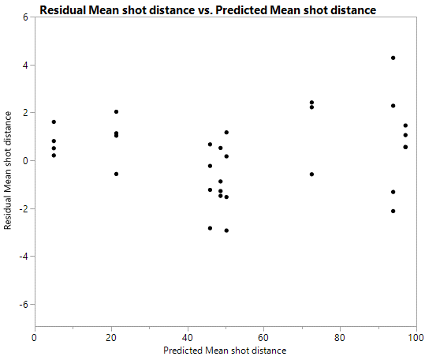 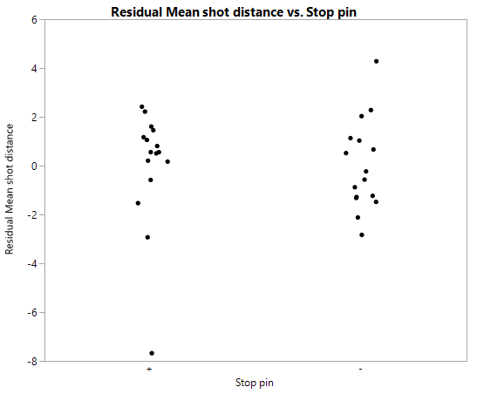

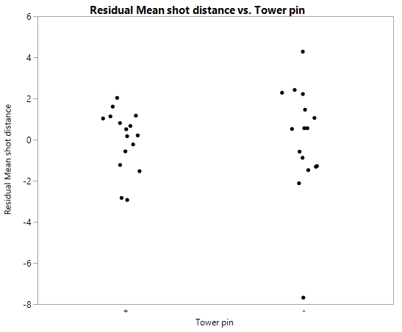 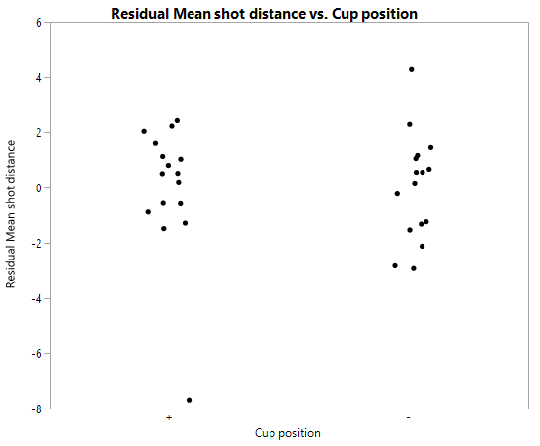

The plot of residual vs predicted shows that there is a similar range of variation across the predicted values and so the plot of residuals vs the factors.

**Regression expression:**

Shot distance = 54.35625-17.45*cup position–23.725*tower pin+1.88125*stop pin–5.16875*cup position*tower pin*stop pin-4.9*tower pin*stop pin

For factor settings, +,-,+

=54.35625 -17.45+23.725-1.88125+5.16875+4.9

=68.81875

This value is approximately equal to the mean shot distance that were recorded.

**Anova analysis for standard deviation of short distance:**

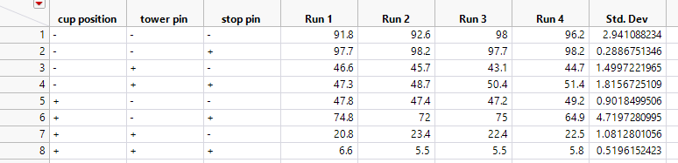

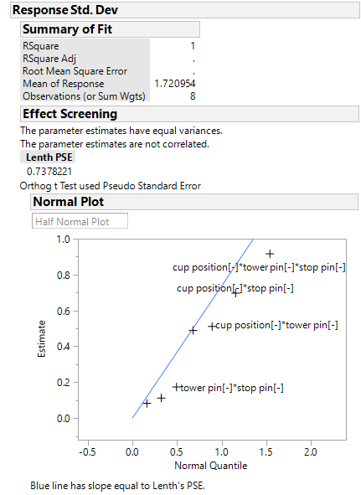

From the half normal plot it can be observed that the tower pin & stop pin, cup position & tower pin, cup position & stop pin and cup position & tower pin & stop pin lies far away from the line. Hence these factors are significant factors.

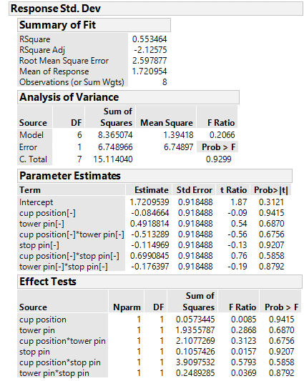

From the effect test we can see that the p value of all factors are greater than $α=0.05$. Hence the factors are not significant. Therefore, we can eliminate two factor interactions and see if that makes any difference.

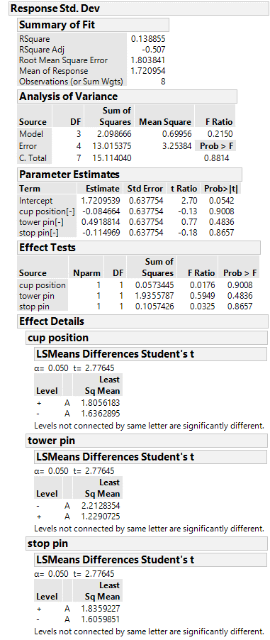

Connecting letters report of factors shows that all levels are connected by same letter and they are not significantly different at $α=0.05$

From the effect test we can see that the p value of all factors are greater than $α=0.05$. Hence the factors are not significant.

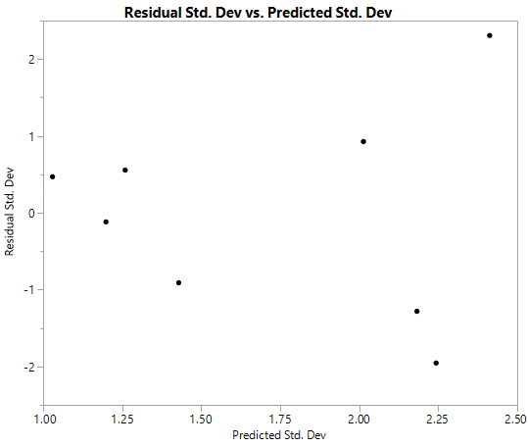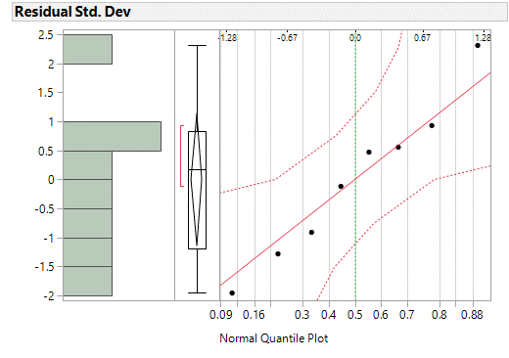

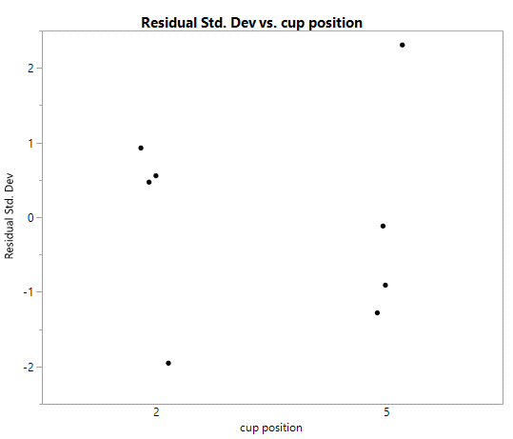 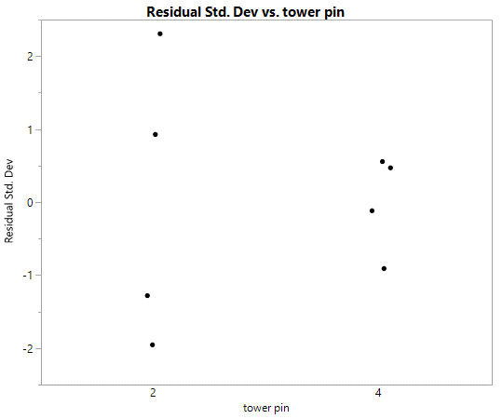

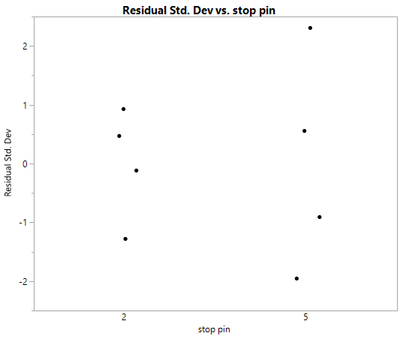

From the normal quantile plot it shows that all points lie close to the line and it’s within the error bound. Hence there is no significant deviation of normality assumption.

From the graph of residual vs predicted shows that there is no unusual pattern of variance.

From the graph residual vs factors there is a similar range of variance for cup position. For tower pin the range of variance is smaller for higher level (4) and for stop pin the range of variance is smaller for lower level (2). There is no strong evidence against equal variance assumption.

**Regression expression for extra setting**

|  |  |  |  |  |  |  |
| --- | --- | --- | --- | --- | --- | --- |
| **Factors** | **Levels** | | | | | |
| **1** | **2** | **3** | **4** | **5** | **6** |
| **Cup position** |  | **1** | **1/3** | **-1/3** | **-1** |  |
| **Stop pin** |  | **1** | **1/3** | **-1/3** | **-1** |  |
| **Tower pin** |  | **1** | **0** | **-1** |  |  |

**Shot distance**

**SHOT DISTANCE=54.3565 -17.45*Cup position -23.725*Tower Pin +1.88125*Stop Pin + 5.1685*Cup position*Tower Pin*Stop pin-4.9*Tower Pin*Stop Pin**

SHOT DISTANCE=54.3565 -17.45*1/3 -23.725*0 +1.88125*(-1/3) + 5.1685*1/3*0 -4.9*0*(-1/3)

**Shot distance=47.913335**

**Conclusion:**

From the ANOVA analysis, it is seen that all the factors that were selected affects the response whereas during the analysis of standard deviation, it could be seen that the same factors were not significant. If there is a change in alpha value, there is a chance of input factor ‘stop pin’ becoming a significant factor. The model was then validated with extra setting and was found that the mean shot distance from extra setting and the actual mean shot distance differs by abput 20cm.

We felt that the impression on aluminium foil to read the distance of the ball was quite difficult. We had to repeat the runs if we missed to notice the location where the ball was first tapped.